APPLICATION WHICH IS TESTED: [www.centurypackersmovers.in](http://www.centurypackersmovers.in)

1. **FUNCTIONAL TESTING:**

Defects Found:

1. Clicking the "Contact Us" button navigates to the contact page, but the button remains highlighted on the home page instead of the contact page in the navigation menu.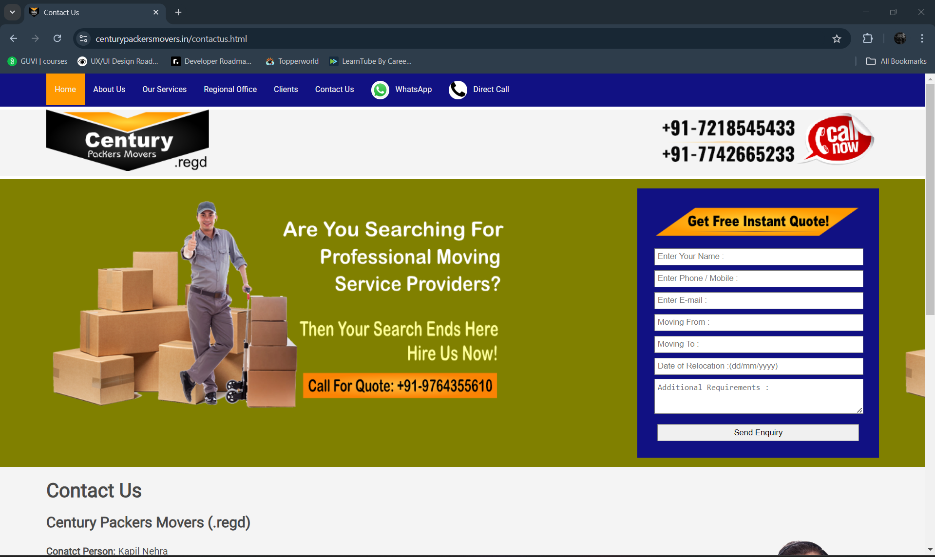
2. When filling the “Get Free Instant Quote” form, no error is shown if a previous month is selected for the relocation date, even though it should not be allowed. 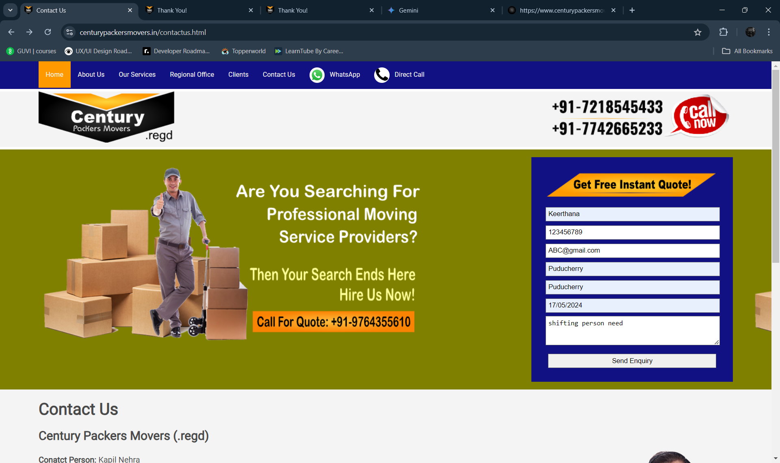
3. **INTEGRATION TESTING:**

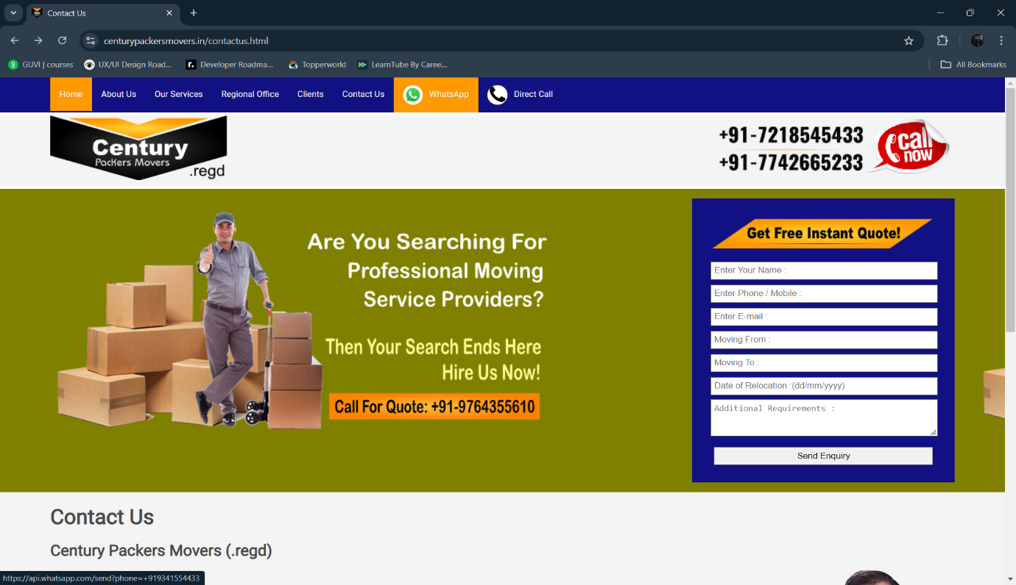Defects Found:  
  
1. Clicking the WhatsApp link redirects to another page, but it results in an incorrect link error, breaking the integration.

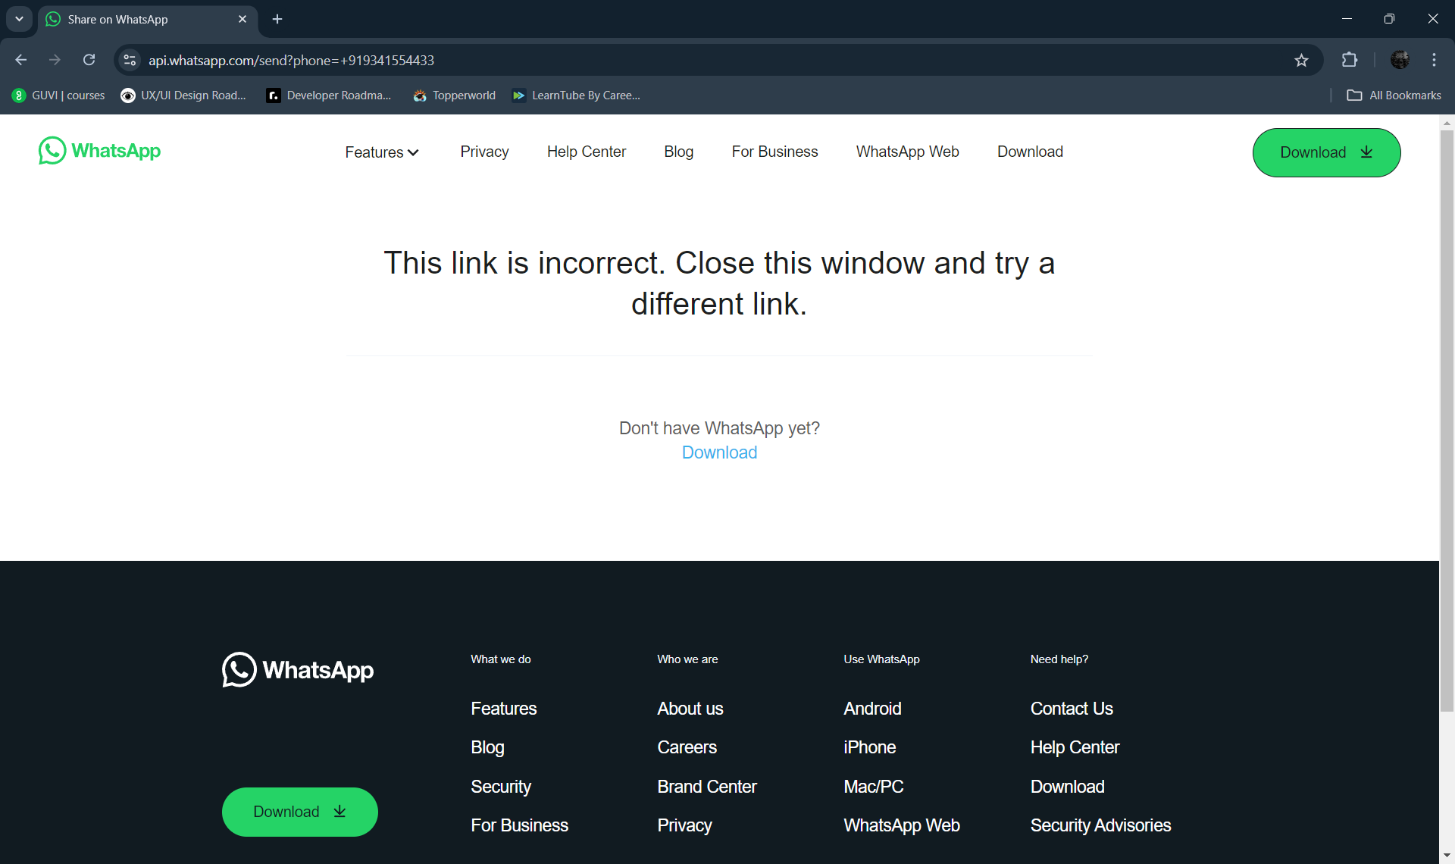

1. When navigating back to the home page, the page takes too long to load, indicating a performance issue with load response times.

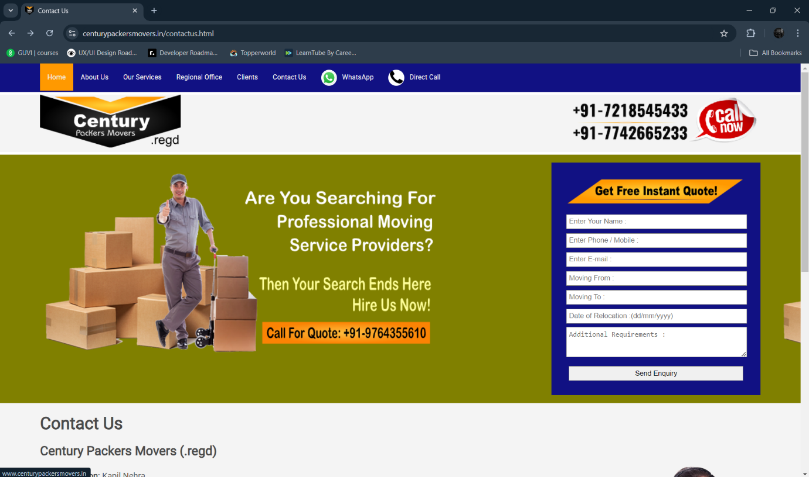

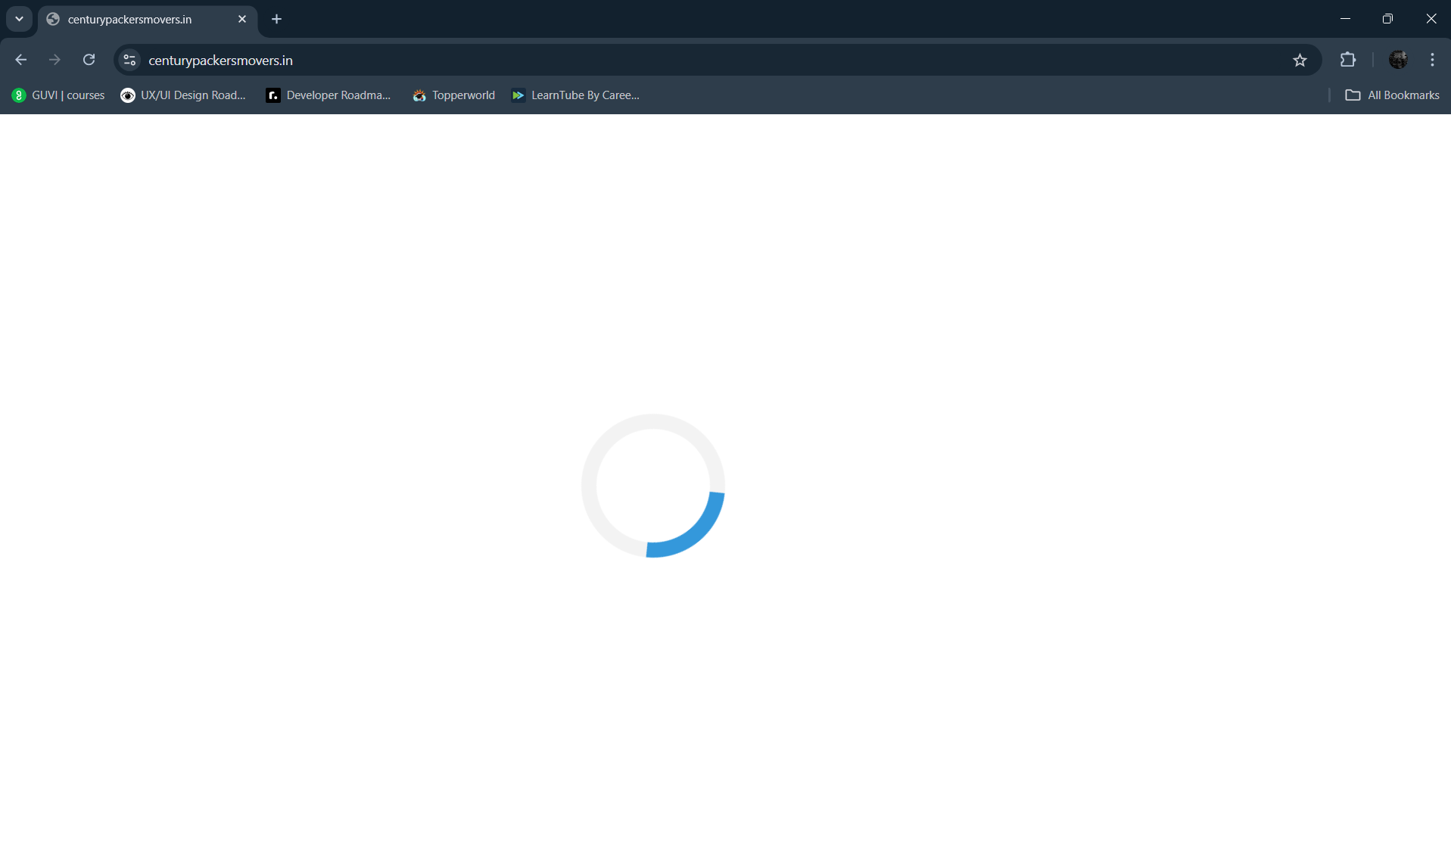

1. **COMPATIBILITY TESTING:**  
   Defects Found:  
     
   1. On mobile Chrome, the homepage background image is missing, but it displays correctly on laptop Chrome. The image formats and their technical details (PNG, 32 bits per pixel, dimensions) vary across devices